**1.1 Introduction**

Glaucoma is a neurodegenerative eye condition in which the patient gets progressively blind due to damage to the optic nerve. The damage to the optic nerve is because of the increase in the intraocular pressure (fluid pressure) of the eye. According to WHO, glaucoma is the second leading cause of blindness; after cataracts. Glaucoma, however, presents a greater public health threat than cataracts because the blindness it causes is irreversible and chronic. Patients with early glaucoma do not usually have any visual signs or symptoms, this makes it very difficult to detect glaucoma in early stages. Progression of the disease leads to loss of vision, which occurs gradually over a long period of time. In South India, studies have shown a glaucoma prevalence rate of 2.6% among the total populace and 90% of the cases have been undiagnosed before, compared to 50% previously undiagnosed cases when similar studies were done in Europe. Detection of glaucoma in early stages is the only way to avoid total vision loss. In healthy eyes, there is normal balance between the fluids, one that is produced in the eye, and the second that leaves the eye through eye’s drainage system. This balance of fluids keeps intraocular pressure within the eye constant but in glaucoma, the balance of fluids produced within the eye is not maintained properly which in turn causes an increase in pressure, resulting in the damage of optic nerve. In this project we have designed a MATLAB (R2016a) based Glaucoma detection system. The system takes HRF (High Resolution Fundus) image as input and detects the presence of glaucoma. This system can be used by ophthalmologists to supplement their own diagnosis. Also, this system can be further modified to predict the approximate amount of time the patient has before complete loss of vision and current degree of glaucoma.

**1.2 Theory**

Since it is the damage to the optic nerve, due to increase in the intraocular pressure, which leads to glaucoma, we have tried to quantify the damage by using image-processing techniques. In glaucoma, the little nerve fibers of the optic nerve are being wiped out along the rim because of the increase in fluid pressure of the eye. This damage to the optic nerve decreases the quality of the optic signal from the optic nerve to the brain, hence leading to blindness. The amount of damage to the optic nerve can be quantified by measuring the cup size, because due to glaucoma the cup size become larger than normal. The following schematic gives the process flow for glaucoma detection.

Acquiring Original Image

Primary Segmentation by using Active Contours

Secondary Segmentation by using Active Contours

Conversion to BW of final ROI

Tracing of Triangle

Area of triangle

Fig. 1 Process Flow

1. Acquiring of HRF image: In this project, we have used HRF (High Resolution Fundus) image dataset of eye because the HRF images are retinal fundus images with high resolution on which segmentation algorithms can be used.
2. Primary segmentation using Active Contour: Active contour model, also called snakes, is a framework in computer vision image processing for delineating an object outline from a possibly noisy 2D image. By using Active Contour, we find the primary region of interest.
3. Secondary segmentation using Active Contour: From the primary region of interest i.e. the cup we find the secondary region of interest using Active Contour. The secondary region of interest consists of the cup and the disc of the fundus image.
4. Conversion to BW image: The secondary image is then converted to black and white image by using a predetermined threshold value. It sets certain elements of the image matrix to white while keeping the rest of them black according to the threshold value.
5. Tracing the triangle: From the final BW image, we find a triangle which helps us to quantify the damage to the optic nerve. This is a very crucial step in detection of glaucomatous eye.
6. Finding the area of triangle: The final step is to find the area of triangle. This area of triangle is then compared with a predetermined value to find if the eye is glaucomatous or non-glaucomatous.

**1.3 Implementation**

There are several possible ways of going about the detection of glaucoma. A number of factors can be diagnosed to pre-empt the shortcomings of the disease. Based on the part of the eye under observation, the treatment of glaucoma can be broadly classified as below:

|  |  |
| --- | --- |
| **Examining** | **Name of the Test** |
| The inner eye pressure | Tonometry |
| Shape and color of the optic nerve | Ophthalmoscopy |
| Complete field of vision | Perimetry |
| Angle in the eye where the iris meets the cornea | Gonioscopy |
| Thickness of the cornea | Pachymetry |

All these aforementioned tests are physical tests. However, the same concept behind these tests can be applied to algorithm which can back the doctor’s diagnosis.

1. Pre-processing :- Once the High Resolution Fundus image is obtained, it needs to processed before it can be worked on by the algorithm. This pre-processing includes tasks like converting the image to a black and white image. This step is necessary as it converts the color image to a grayscale image which is a vector of 1’s and 0’s that make it easy for the algorithm to operate on. It is also essential to select a standard size for all images so that the masks used ahead are applicable appropriately. The functions used in this part are: imread :- It reads the image mentioned into a vector.

ndims :- Returns the number of dimensions of an array.

resize :- Resizes the vector to the required numbers of rows and columns.

1. Initial (Primary) Segmentation :- This part runs the segmentation algorithm to single out the required part of the HRF image. HRF images consist of the macula (the centre of the image) and the optic disk is located towards the nose. We are more interested in the optic disk hence we zone out the rest of the image. Functions used are:(i)zeros:- It is used to create an array of zero (ii) activecontour :- Runs active segmentation (contouring)

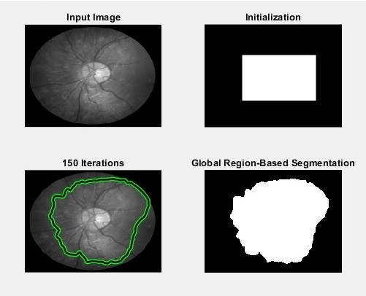

Fig.2 Pre-processing and Primary Segmentation

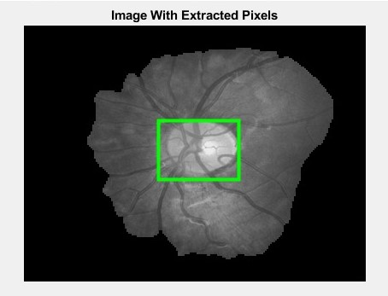

Fig.3 Image after primary segmentation with detected ROI

1. Secondary Segmentation :- The segmented image is now further made smaller by selecting the part of the scan that we are most interested in. This is called the Region Of Interest (ROI). It is obtained by using a function called ‘regionprops’ that returns a region with its specific required properties. Now that we have the Region Of Interest (ROI), we can further process this image to segregate the blood vessels and nerve fibers out, to obtain the pure form of the optic disk. This is necessary to calculate the area of the sector formed and hence determine whether it is a glaucomatous eye or not. The contour image needs to be reformatted so as to make it a pure black and white image. The necessary changes are also reflected back on the original grayscale image for showing the changes.

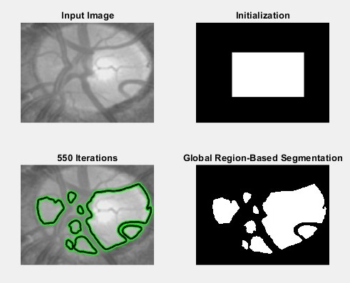

Fig.4 Secondary Segmentation

1. Tracing the triangle :- The previous step results in a black and white image that highlights the ROI without the blood vessels and nerve fibers. This helps us find the area of the optic disk. This triangle is to be traced by the doctor that covers the optic disk as much as possible. This triangle is now isolated and marked only by its edges. This is done using the following functions :-

(i) roipoly :- Enables the user to mark points the required polygon (triangle)

(ii) edge :- Highlights only the edges of the figure

(iii) find :- Returns the indices of non zero elements in an array.

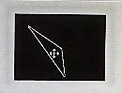

Fig.5 Traced Triangle

1. Final Computations :- Using the ‘area’ function, the area of this triangle is calculated with relative ease and compared with the standard value. Now, how this works is, if the intraocular pressure is very high, the optic disk becomes smaller which causes glaucoma in the long run. As a result of this, the inscribed triangle of ours that actually covers the optical disk part also gets smaller and the area gets smaller. In short, the intraocular pressure directly affects the area of the triangle. This is how we can detect glaucoma from an HRF.

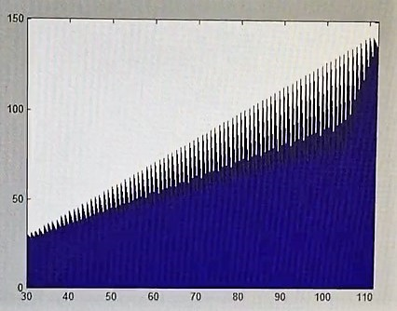

Fig.6 Area Gradient

**1.4 Result**

At the end of this project, we have successfully detected, upto a certain accuracy, the presence of glaucoma from a High Resolution Fundus (HDF) image. The area calculated from the triangle can be plotted as below as it is a 2-D array. This plot can be used to broadly generalize the detection of the disease. Using this approach, the doctor can confirm his diagnosis or correct it incase of misjudgement. This project also displays all the stages of the processing so that it is easy to identify any discrepancy in the process. The aforementioned code is applicable to both HRF i.e the left eye scan as well as the right eye scan. Hence, this process is more convenient and universal as nothing needs to be altered for another dataset.

**1.5 Conclusion**

Glaucoma detection is an absolute must while glaucoma is in its early stages as it is best prevented and treated before it becomes irreversible and chronic. If it is not detected in time, it can lead to permanent blindness. The area gradient can be studied to analyze the onset of glaucoma, i.e if the size of the optical disk has increased.

This project is a sample of one of the many methods that can be used to analyze the HRF scans. Further improvements can be made on this code, so as to also predict the time of onset of glaucoma. It can also predict how much time it would take to cure glaucoma if it is detected in time.

The proposed method achieves an average accuracy of 94% and has an average computational cost of 1.42 seconds. Other algorithms like the Hill Climbing algorithm averages at 90% accuracy. If this accuracy average can be increased, this method can replace the traditional methods of glaucoma detection and can be used by doctors as the foremost method of diagnosis. This can not only reduce visit times, but also drive down the costs of the procedure by avoiding expensive equipments needed otherwise.